CHAPTER 8: Chemical change
Worksheet 8.4

Describing chemical changes
Student: Class:

Converting observations into word equations

1. For each experiment, write a word equation.

Experiment 1. Burning steel (iron) wool in chlorine
The gas jar contained greenish-yellow chlorine gas. The piece of steel wool was teased out and then held with tongs in a blue Bunsen burner flame to get it hot. The hot steel was then plunged into the gas jar and the lid replaced. The steel wool glowed very hot and clouds of a brown smoke appeared. The particles of the smoke were composed of iron chloride. They eventually settled to the base of the jar but some clung to the sides.
Word equation:

Experiment 2. Reducing lead oxide with carbon
A small hollow was ground into the surface of a black carbon (graphite) block. A small sample of yellow lead oxide was placed in the hollow. A blue Bunsen burner flame was directed onto the yellow powder and a blow pipe was used to direct air onto the heated material. The powder glowed and gradually turned grey. During the heating, the graphite converted the yellow powder into silvery beads of lead. Gases that were collected in another experiment showed that colourless carbon monoxide was also produced.
Word equation:

Particle diagrams
2. For each of the word equations above you will use the particle diagrams provided to construct a model of the chemical reactions occurring. An example has been done for you.
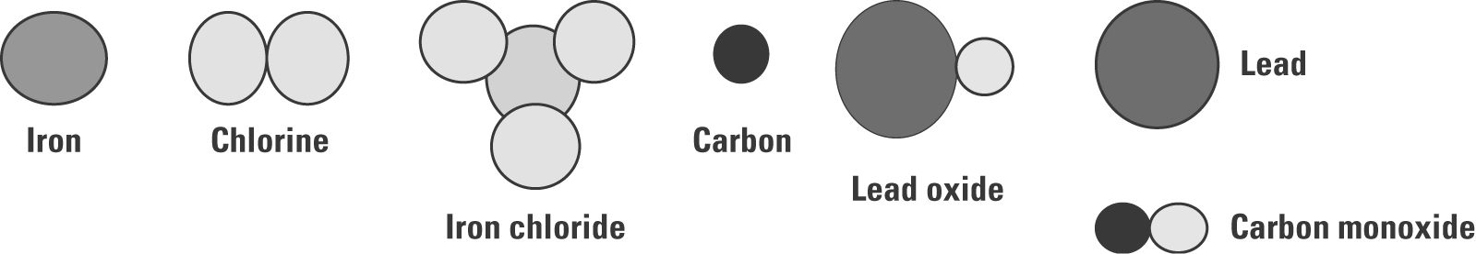

Example: hydrogen + oxygen → water

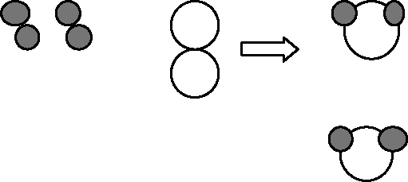

Note: The number of atoms of each type does not change.

Experiment 1 | Experiment 2

